**PIZZA SALES SQL QUERIES**

**A. KPI’s**

**1. Total Revenue:**

select sum(total_price) as TOTAL_REVENUE from pizza_sales;

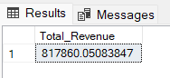

1. **Average Order Value**

select sum(total_price) / count (distinct order_id) as AVERAGE_ORDER_VALUES

FROM pizza_sales;

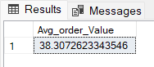

1. **Total Pizzas Sold**

select sum(total_price) / count (distinct order_id) as AVERAGE_ORDER_VALUES

FROM pizza_sales;

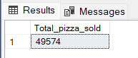

**4. Total Orders**

select COUNT(DISTINCT order_id) as TOTAL_ORDERS from pizza_sales;

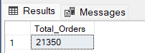

**5. Average Pizzas Per Order**

SELECT CAST(CAST(SUM(quantity) AS DECIMAL(10,2)) /

CAST(count(distinct order_id) AS DECIMAL(10,2)) AS DECIMAL (10,2))

as AVERAGE_PIZZAS_PER_ORDER from pizza_sales;

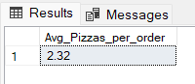

**B. Daily Trend for Total Orders**SELECT DATENAME(DW,order_date) as ORDER_DAY , count(distinct order_id) as TOTAL_ORDERS

from pizza_sales

group by DATENAME(DW,order_date),DATEPART(DW,order_date)

ORDER BY DATEPART(DW,order_date);

***Output:***

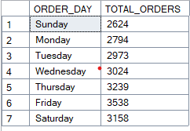

**C. Hourly Trend for Orders**

SELECT DATEPART(HOUR,order_time) as ORDER_HRS ,

count(distinct order_id) as TOTAL_ORDERS

from pizza_sales

group by DATEPART(HOUR,order_time)

order by ORDER_HRS DESC;

***Output***

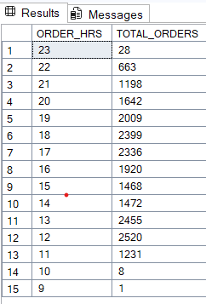

**D. % of Sales by Pizza Category**

SELECT pizza_category,CAST(sum(total_price) AS DECIMAL(10,2)) AS TOTAL_REVENUE,

CAST(sum(total_price) * 100 / (select sum(total_price) from pizza_sales) AS DECIMAL(10,2)) AS PCT

from pizza_sales

group by pizza_category

ORDER BY PCT DESC;

***Output***

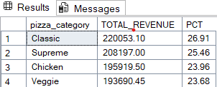

**E. % of Sales by Pizza Size**

SELECT pizza_size,CAST(sum(total_price) AS DECIMAL(10,2))AS TOTAL_REVENUE ,

CAST(sum(total_price) * 100 / (select sum(total_price) from pizza_sales ) AS DECIMAL(10,2)) AS PCT

from pizza_sales

group by pizza_size

ORDER BY pizza_size;

***Output***

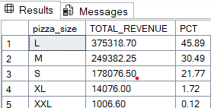

**F. Total Pizzas Sold by Pizza Category**

select pizza_category,sum(quantity) as Total_Pizzas_sold

from pizza_sales

group by pizza_category;

***Output***

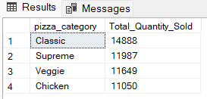

**G. Top 5 Best Sellers by Total Pizzas Sold**

SELECT Top 5 pizza_name, SUM(quantity) AS Total_Pizza_Sold

FROM pizza_sales

GROUP BY pizza_name

ORDER BY Total_Pizza_Sold DESC

***Output***

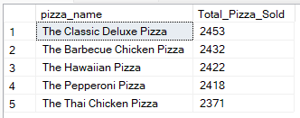

**H. Bottom 5 Best Sellers by Total Pizzas Sold**

SELECT TOP 5 pizza_name, SUM(quantity) AS Total_Pizza_Sold

FROM pizza_sales

GROUP BY pizza_name

ORDER BY Total_Pizza_Sold ASC

***Output***

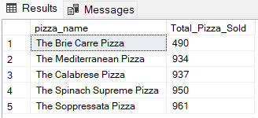

***NOTE***

If you want to apply the Month, Quarter, Week filters to the above queries you can use WHERE clause. Follow some of below examples

SELECT DATENAME(DW, order_date) AS order_day, COUNT(DISTINCT order_id) AS total_orders

FROM pizza_sales

WHERE MONTH(order_date) = 1

GROUP BY DATENAME(DW, order_date)

*\*Here MONTH(order_date) = 1 indicates that the output is for the month of January. MONTH(order_date) = 4 indicates output for Month of April.*

SELECT DATENAME(DW, order_date) AS order_day, COUNT(DISTINCT order_id) AS total_orders

FROM pizza_sales

WHERE DATEPART(QUARTER, order_date) = 1

GROUP BY DATENAME(DW, order_date)

*\*Here DATEPART(QUARTER, order_date) = 1 indicates that the output is for the Quarter 1. MONTH(order_date) = 3 indicates output for Quarter 3.*